1. 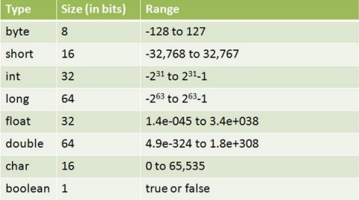
2. A. Legal (data range -128 to 127)

C. Legal (data range -128 to 127)

D. Legal (data range -128 to 127)

E. Legal (data range -32 768 to 32 767)

G. Legal (data range -32 768 to 32 767)

H. Legal (data range -32 768 to 32 767)

1. A. Legal (char variable can added one letter)

B. Legal (char variable can added one number)

D. Legal (Boolean variable can added true)

F. Legal (Boolean variable can added false)

|  |  |  |  |  |
| --- | --- | --- | --- | --- |
| **No** | **Decimal** | **Binary** | **Octal** | **Hexadecimal** |
| **A.** | **10** | 1010 | 12 | A |
| **B.** | **16** | 10000 | 20 | 10 |
| **C.** | **128** | 10000000 | 200 | 80 |
| **D.** | **255** | 11111111 | 377 | FF |
| **E.** | **32767** | 111111111111111 | 77777 | 7FFF |
| **F.** | **1** | 1 | 1 | 1 |
| **G.** | **0** | 0 | 0 | 0 |
| **H.** | **26** | 11010 | 32 | 1A |
| **I .** | **31** | 11111 | 37 | 1F |

1. A. 11110110

B. 10011100

C. 11000000

D. 11111111

E. 11111101

F. 10000000

G. 00000000

H. 10000000

I . 11100000

1. 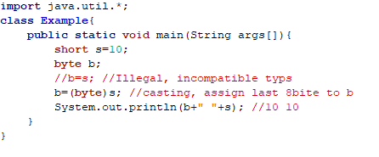A. Casting: Data type is converted into another data type by a programmer using casting operator.

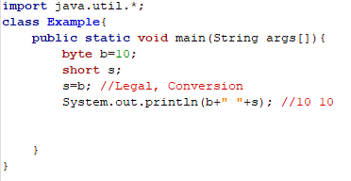 Conversion: A data type is converted into another data type by a compiler

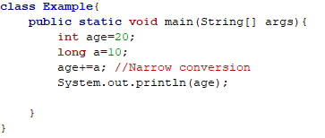B. Narrow Conversion: long range data type converted into short range data type by a compiler.

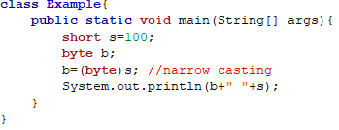 Narrow Casting: Long range data type converted into short range data type by a programmer using casting operator

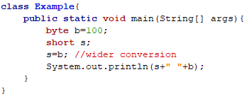 C. Wider Conversion: Short range data type converted into long range data type by a compiler.

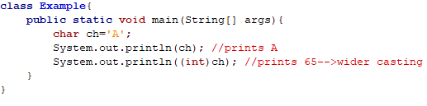 Wider Casting: Short range data type converted into long range data type by a programmer using casting operator

1. A

E

1. 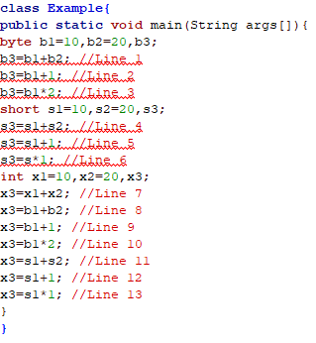

Adding two-byte variables or two short variables can be assigning an int variable only.

1. A C and E
2. A and B
3. B
4. A B and D
5. A B C D
6. 0 to 65535
7. A C and G
8. A. 3

B. -3

C. 3

D. -3

E. 3

F. -3

G. 3

1. Line 1

Line 2

Line 4

1. A D and E
2. A B C and D
3. A. 17

B. -10

C. -17

D. -3

E. 7

F. -3

1. 
2. 
3. 
4. 
5. 
6. A. 3

B. 0

C. 10

D. 0.0

E. 1.0999999999999996

1. A. 30

B. -10

C. 31

D. 31

E. 33

F. 34

G. 38

H. 39

1. X = 12 - 4 * 2

X = 12 – 8

X = 4

X = (12 – 4)*2

X = 8 * 2

X = 16

X = 12 – (4*2)

X = 12 - 8

X = 4

1. A. X = 7%10/2*2

= 7/2*2

= 3*2

= 6

B. X = 7%(10/2)*2

= 7%5*2

= 2*2

= 4

C. X = 7%10/(2*2)

= 7%10/4

= 7/4

= 1

D. X = 7%(10/(2*2))

X = 7%(10/4)

X = 7%2

X = 1

E. X = 7%((10/2)*2)

X = 7%(5*2)

X = 7%10

X = 7

1. A. a=a+(a=6)

=100+(a=6)

=6

B. a=(a=6)+a

=6+6

=12

C. a=(a=6)+(a=5)

=6+5

=11

D. a=a*3+a

=11*3+11

=44

1. A. x=a++ + a

=10+11

=21

B. x=a + a++

=11+11

=22

C. x=++a + a

=13+13

=26

D. x=a + ++a

=13+14

=27

E. x=++a + ++a

=15+16

=31

F. x=a++ + a++

=16+17

=33

G. x=++a + a++

=19+19

=38

H. x=a++ + ++a

=20+22

=42

